**THE UNITED REPUBLIC OF TANZANIA**

**LONGIDO DISTRICT COUNCIL**



**LAND TENURE IMPROVEMENT PROJECT (LTIP)**

**ENVIRONMENTAL AND SOCIAL MANAGEMENT PLAN FOR RURAL CERTIFICATION PROCESS IN LONGIDO DISTRICT COUNCIL**

**Prepared by:**

**LONGIDO DISTRICT COUNCIL**

**February 2024**

**LONGIDO DISTRICT ESMP TEAM**

|  |  |  |
| --- | --- | --- |
| NAME | PROFESSION/POSITION | ORGANIZATION |
| Sofia Sylivery Gashomba | Environmental Officer | Longido District Council |
| Denis John Silayo | Social Development Officer | Longido District Council |
| Alpha Mangula | Environmental and Social Management Coordinator, Land Tenure Improvement Project (LTIP) | Ministry of Lands, Housing and Human Settlement Development (MLHHSD) |
| Tumaini Setumbi | Social Development Officer, Land Tenure Improvement Project (LTIP) | MLHHSD |
| Robert Kishiki | Social Development Specialist, Land Tenure Improvement Project (LTIP) | MLHHSD |
| Regina Kabwogi | Environmental Specialist, Land Tenure Improvement Project (LTIP) | MLHHSD |

Table of Contents

**LIST OF ABBREVIATIONS AND ACRONYMS** v

CHAPTER ONE 1

INTRODUCTION 1

1.1. Background Information 1

1.2. LTIP Project Scope in Longido District Council 1

District Land Use Planning Framework (DLUPF) 3

Village Land Use Plans (VLUP) and 3

Issuance of CCROs 4

1.3. General Objectives of ESMP 4

1.4. Methodology for Preparation of ESMP 5

CHAPTER TWO 6

BASELINE ADMINISTRATIVE, ENVIRONMENTAL AND SOCIAL CONDITION OF THE PROJECT AREA 6

2.1 Introduction 6

2.2 Administrative Condition of Longido District Council 6

2.3 Environmental Baseline Information in Longido District Council 7

2.4 Longido District Council Social Baseline Information 11

CHAPTER THREE 15

LEGAL AND INSTITUTIONAL FRAMEWORK 15

3.1 Introduction 15

3.2 Country’s Legal Framework to Guide Land Use Planning and Rural Certification Processes in Longido District 15

3.3 World Bank Environmental and Social Framework 17

CHAPTER FOUR 19

ENVIRONMENTAL AND SOCIAL IMPACTS, RISKS AND MITIGATION MEASURES 19

4.1 Introduction 19

4.2 Project Social Benefits 19

4.3 Negative Social Risks and Impacts of Land Use Planning and Rural Land Certification 19

4.4 Project Positive Environmental Impacts of Land Use Planning and Land Certification 21

4.5 Negative Environmental Impacts of Land Use Planning and Land Certification 22

4.6 Mitigation Measures of the Identified Impact 22

CHAPTER FIVE 31

Monitoring of Environmental and Social Impacts 31

5.1 Introduction 31

CHAPTER SIX 37

INSTITUTIONAL ARRANGEMENTS FOR IMPLEMENTATION OF ESMP IN LONGIDO DISTRICT COUNCIL 37

6.1 Introduction 37

6.2 ESMP Implementing Institutions in Longido District Council 37

6.3 Supervision and Monitoring Roles 38

6.4 Capacity Development and Training 38

CHAPTER SEVEN 39

CONCLUSIONS AND RECOMMENDATIONS 39

7.1 Introduction 39

7.2 Conclusions 39

7.3 Recommendations 40

**LIST OF TABLES**

**Table 1: Project Areas at Longido District Council** 1

**Table 2: Land categories in Longido District** 6

**Table 2: Hunting Blocks** 11

**Table 3: Mitigation Measures of Identified Impacts** 21

**Table 4: Social and Environmental Monitoring Plan for Implementation of Mitigation Measures during Land Certification and Registration Process in Longido District Council** 29

**Table 5: Training conducted to Longido E&S Team** 34

**LIST OF FIGURES**

Figure 1: Administrative Map of Longido showing 18 Wards 6

Figure 2: Land categories in Longido (Source: Longido District Council, 2023). 7

Figure 3: Map of Wildlife Corridors in Longido District 8

Figure 4: Grazing Areas in Longido District 9

**LIST OF ABBREVIATIONS AND ACRONYMS**

|  |  |  |
| --- | --- | --- |
|  |  |  |
| CBO | - | Community Based Organization |
| CCRO | - | Certificate of Customary Right of Occupancy |
| CoC | - | Code of Conduct |
| CRO |  | Certificate of Right of Occupancy |
| DED |  | District Executive Director |
| DEMO | - | District Environmental Management Officer |
| DLHT | - | District Land and Housing Tribunal |
| E&S | - | Environmental and Social |
| EA | - | Environmental Assessment |
| EIA | - | Environmental Impact Assessment |
| EIAR | - | Environmental Impact Assessment Report |
| EIS | - | Environmental Impact Statement |
| EHSG |  | Environmental Health and Safety Guidelines |
| EMA | - | Environmental Management Act 2004 |
| EMO | - | Environmental Management Officer |
| ES | - | Environmental Screening |
| ESCP | - | Environmental and Social Commitment Plan |
| ESMT | - | Environmental and Social Management Team |
| ESMF | - | Environmental and Social Management Framework |
| ESMP | - | Environmental and Social Management Plan |
| ESF |  | Environmental and Social Framework |
| ESS | - | Environmental and Social Standard |
| FPIC | - | Free, Prior and Informed Consent |
| GDP | - | Gross Domestic Product |
| GBV | - | Gender Based Violence |
| GoT | - | Government of Tanzania |
| GRM | - | Grievance Redress Mechanism |
| HIV/AIDS | - | Human Immunodeficiency Virus/Acquired Immuno- Deficiency Syndrome |
| ILMIS | - | Integrated Land Management Information System |
| LGAs | - | Local Government Authorities |
| LTAP | - | Land Tenure Assistance Project |
| LTIP | - | Land Tenure Improvement Project |
| LTSP | - | Land Tenure Support Project |
| M&E | - | Monitoring and Evaluation |
| MLHHSD | - | Ministry of Land, Housing and Human Settlement Development |
| NEMC | - | National Environment Management Council |
| NGO | - | Non-Governmental Organisation |
| NSC | - | National Steering Committee |
| OHS | - | Occupational Health and Safety |
| OM | - | Operational Manual |
| PCU | - | Project Coordinating Unit |
| PLUM | - | Participatory Land Use Management |
| PO-RALG | - | President’s Office Regional Administration and Local Government |
| Rl | - | Residential License |
| RPF | - | Resettlement Policy Framework |
| SEA | - | Sexual Exploitation and Abuse |
| SEP |  | Stakeholder Engagement Plan |
| TNA | - | Training Needs Assessment |
| TOR | - | Terms of Reference |
| URT | - | United Republic of Tanzania |
| VLUM | - | Village Land Use Management (Committee) |
| VLUP | - | Village Land Use Plan |
| VG | - | Vulnerable Groups |
| VGPF | - | Vulnerable Groups Planning Framework |
| WB | - | World Bank |
| WEO | - | Ward Executive Officer |

# CHAPTER ONE

# INTRODUCTION

## Background Information

The Government of Tanzania (GoT) through the Ministry for Lands, Housing and Human Settlements Development (MLHHSD) is implementing Land Tenure Improvement Project (LTIP). The Project Development Objectives (PDO) are to strengthen the national land administration system and increase tenure security in selected areas for both men and women.. LTIP promotes land-based investments and ensures inclusion for social economic development in both urban and rural areas. Key project results indicators related to the PDO to increase tenure security include the registration of 1 million Certificates of Rights of Occupancy (CROs), one million Residential Licenses (RL), and 500,000 Certificates of Customary Rights of Occupancy (CCROs). At least 40 percent of the land certificates should be registered under the name of women, as sole owners, or co-owners. Project investments are also expected to support a reduction of at least 30 percent in the number of land conflicts, as well as an increase in perception of tenure security. Results indicators related to the PDO to strengthen the national land administration system include an increase of 20 percent in the number of CRO transactions, a reduction of the average time to issue CROs (first registration) from 180 days to 60 days.

## LTIP Project Scope in Longido District Council

The Longido District Council is one of beneficiaries of LTIP activities. In Longido the project is expected to support the preparation of District Land Use Planning Framework (DLUPF), Village Land Use Plans (VLUP), and Detail Settlement Plan (DSP) covering the settlement part of the villages, as well as the issuance of CCROs, renovation/creation of district and village land offices. This ESMP is prepared specifically to guide the preparation of DLUPF, VLUP, DPS, and issuance of CCROs activities covering all 50 villages (see table 1) while the ESMPs for district and village land offices will be developed later before commencement of the renovation activities.

##### **Table 1: Longido District Council- Project Coverage Villages**

| **NO.** | **Ward** | **Village** | **Registration Date** | **Village Registration Number V** |
| --- | --- | --- | --- | --- |
| 1 | Elang’atadapash | Elangátadapash | 20.02.1979 | ARS-080-09001193 |
| 2 | Elang’atadapash | Olchoronyokye | 01.01.2000 | ARS-080-09010722 |
| 3 | Elang’atadapash | Sokon | 01.07.2009 | ARS-080-09011489 |
| 4 | Noondoto | Noondoto | 01.07.1979 | ARS-080-09010124 |
| 5 | Noondoto | Engusero | 01.01.2000 | ARS-080-09001261 |
| 6 | Ketumbeine | Orkejuloongishu | 20.02.1979 | ARS-080-09010787 |
| 7 | Ketumbeine | Engushai | 01.07.2014 | ARS-080-09001265 |
| 8 | Ketumbeine | Armanie | 01.09.2012 | ARS-080-09000034 |
| 9 | Ketumbeine | Lopolosek | 01.07.2014 | ARS-080-09005215 |
| 10 | Ilorienito | Ilorienito | 20.02.1979 | ARS-080-09002191 |
| 11 | Ilorienito | Nadaare | 01.07.2014 | ARS-080-09009214 |
| 12 | Ilorienito | Losirwa | 01.01.2000 | ARS-080-09005226 |
| 13 | Gelai Meirugoi | Meirugoi | 01.09.2012 | ARS-080-09006966 |
| 14 | Gelai Meirugoi | Loondolwo/Esirwa | 01.09.2012 | ARS-080-09005211 |
| 15 | Gelai Meirugoi | Magadini | 01.09.2012 | ARS-080-09005738 |
| 16 | Gelai Lumbwa | Lumbwa | 01.09.2012 | ARS-080-09005429 |
| 17 | Gelai Lumbwa | Alaililai | 01.07.2014 | ARS-080-09000010 |
| 18 | Gelai Lumbwa | Ilchangitsapukin | 01.09.2012 | ARS-080-09002126 |
| 19 | Gelai Lumbwa | Wosiwosi | 01.09.2012 | ARS-080-09012251 |
| 20 | Engarenaibor | Ngoswak | 01.01.2000 | ARS-080-09009896 |
| 21 | Engarenaibor | Mairowa | 01.07.1979 | ARS-080-09005914 |
| 22 | Engarenaibor | Karao | 01.09.2012 | ARS-080-09003233 |
| 23 | Engarenaibor | Sinonik | 01.09.2012 | ARS-080-09011456 |
| 24 | Engarenaibor | Kimwati | 01.09.2012 | ARS-080-09004060 |
| 25 | Mundarara | Mundarara | 01.07.1994 | ARS-080-09008509 |
| 26 | Mundarara | Orgira | 01.09.2012 | ARS-080-09010784 |
| 27 | Mundarara | Orpurkel | 01.09.2012 | ARS-080-09010797 |
| 28 | Mundarara | Lesing'ita | 01.07.1994 | ARS-080-09005026 |
| 29 | Matale A | Matale A | 01.09.2012 | ARS-080-09006552 |
| 30 | Matale A | Matale B | 01.09.2012 | ARS-080-09006553 |
| 31 | Engikaret | Engikaret | 28.10.1980 | ARS-080-09001252 |
| 32 | Engikaret | Kiserian | 01.01.2000 | ARS-080-09004301 |
| 33 | Kimokouwa | Kimokouwa | 28.08.1980 | ARS-080-09004053 |
| 34 | Kimokouwa | Eworendeke | 01.01.2000 | ARS-080-09001277 |
| 35 | Orbomba | Orbomba | 01.09.2012 | ARS-080-09010783 |
| 36 | Orbomba | Oltepesi | 01.09.2012 | ARS-080-09010761 |
| 37 | Orbomba | Ranchi | 01.09.2012 | ARS-080-09010910 |
| 38 | Longido | Longido | 01.06.1979 | ARS-080-09005202 |
| 39 | Olmolog | Elerai | 27.07.1993 | ARS-080-09001195 |
| 40 | Olmolog | Olmolog | 15.11.2005 | ARS-080-09010749 |
| 41 | Olmolog | Lerang’wa | 15.11.2005 | ARS-080-09005012 |
| 42 | Kamwanga | Kamwanga | 01.07.1979 | ARS-080-09003113 |
| 43 | Kamwanga | Kitenden | 01.01.2000 | ARS-080-09004436 |
| 44 | Kamwanga | Irkaswa | 01.09.2012 | ARS-080-09002337 |
| 45 | Tingatinga | Tingatinga | 01.09.2012 | ARS-080-09011702 |
| 46 | Tingatinga | Ngereyani | 01.09.2012 | ARS-080-09009833 |
| 47 | Sinya | Ildonyio | 01.07.2014 | ARS-080-09002127 |
| 48 | Sinya | Leremeta | 01.07.2014 | ARS-080-09005022 |
| 49 | Sinya | Endonyemali | 01.07.2014 | ARS-080-09001243 |
| 50 | Namanga | Namanga | Township | Township |

In Longido District Council, the preparation of DLUPF, VLUP, DSP, and the issuance of CCROs ism expected to involve the following activities:

## District Land Use Planning Framework (DLUPF)

LTIP provided initial support for the preparation of DLUPF in March 2023 and this support involved stakeholder engagement, awareness raising and training; capacity development to the planning and district staff and management teams; data collection; establishing baseline data; and a District Stakeholder Engagement Forum, which was held in the Longido District on July 23, 2023. The Forum provided an opportunity for all stakeholders to discuss and deliberate land use change proposals within the Longido district.. The preparation of DLUPF was suspended at the draft stage due to uncertainties and possible disagreements regarding the land use situation in the district. The Forum concluded that further work was required for stakeholders to reach consensus on the proposed DLUFP, and the DLUFP preparation process is on hold while an approach to reaching consensus is developed. If an agreement is reached on how to proceed, LTIP may support the preparation of the DLUFP, and MLHHSD will ensure that the DLUFP preparation process includes an adequate assessment of Environmental and Social (E&S) implication and the formulation of advice for addressing these in ways that are consistent with the World Bank’s Environmental and Social Framework.

## Village Land Use Plans (VLUP) and

There are 50 village formally registered in Longido, of which already 27 already have VLUP. LTIP is expected to support the preparation of VLUP and DSP for the remaining 23 villages, as this is a prerequisite for the issuance of CCROs. The preparation of VLUPs will involve awareness creation and capacity building for the Participatory Land Use Management Team (PLUM); conduct village assembly and formulation of Village Land Use Management Council (VLUM); preparation of baseline information which include resource assessment, existing land use and existing environmental and social issues; preparation of draft Village Land Use Plan (VLUP); validation and approval of the proposed VLUP and respective by-laws by the village assembly; endorsement of the VLUP by the district council; gazettement of the approved VLUP by the National Land Use Planning Commission. For each VLUP and DSP, LTIP will support an adequate assessment of E&S implication and the formulation of advice for addressing these in ways that are consistent with the World Bank’s ESF.

## Issuance of CCROs

The process of issuance of CCROs is detailed in the LTIP CCRO Manual and shall involve five (5) major activities namely:

1. Public awareness and engagement of Vulnerable Groups (VG);
2. Employing and Training of Parasurveyors;
3. Parcels adjudication;
4. Preparation of DPS (regularization layout);
5. Block Planning and Negotiation of Road Accessibility
6. Printing and issuing CCROs.

For issuance of CCROs in Longido district, for all villages with VLUPs the project will develop a negative list of VLUPs which contain risks that the project cannot support (such as VLUPs which require the displacement of people or destruction of natural habitat to enforce for example and as outlined in Annex 6 of the ESMF). These would be used to preclude the issuance of CCROs under the project. To issue CCROs in some villages for where VLUPs were prepared outside the project, the Project shall undertake appropriate due diligence to ensure these VLUPs were developed under a similarly participative approach which focuses on existing land use, avoids exclusion and elite capture, and avoids community and/or environmental harm. Attached due diligence checklist, will be used.

## General Objectives of ESMP

The preparation of the Longido DLUPF, VLUPs, DSPs and issuance of CCRO have potential to cause E&S impacts. The Longido ESMP is a tool for identifying, mitigate, and monitoring the E&S impacts associated with these activities. Specifically, it depicts how the organizational capacity and resources will be utilized to assess these impacts, define mitigation measures, and implement them when appropriate. Therefore, the Government’s implementation team, as well as Non Governmental Organizations (NGOs) that are expected to be hired under LTIP to support rural land certification, will implement project activities in accordance with this ESMP.

The preparation of this ESMP is consistent with the Project’s Environmental and Social Management Framework (ESMF) and aims at attaining the following objectives:

1. Identify potential E&S risks and impacts associated with land use planning and rural certification activities support by LTIP;
2. Develop mitigation/enhancement measures to minimize E&S risks and impacts;
3. Define implementation arrangement and organization structure of ESMP implementation;
4. Identify the parameters to be monitored and the respective tools that are used in monitoring and reporting.

## Methodology for Preparation of ESMP

This ESMP has been prepared by the district Participatory Land Use Management Team(PLUM) of Longido District Council in collaboration with the LTIP-ESMT through the following activities.

1. Undertake an E&S screening to determine risks and impacts associated with certification process using: (i) Annex 4 of ESMF on Screening Checklists for environmental and social issues; (ii) Annex 6: Environmental and Social Safeguards Criteria for selecting project specific areas; and (iii) Annex 5: Terms of Reference for the preparation of ESMP.
2. Define mitigation, enhancement and monitoring measures for the identified impacts;
3. Validation of mitigation, enhancement and monitoring measures through stakeholders’ engagement.
4. Finalization of ESMP report, and sharing with wider stakeholders, including through its publication on the LTIP website.

# CHAPTER TWO

# BASELINE ADMINISTRATIVE, ENVIRONMENTAL AND SOCIAL CONDITION OF THE PROJECT AREA

* 1. Introduction

The baseline environmental and social conditions of Longido district describe biophysical and social issues which are likely to be affected, trigger conflicts or are of biological importance in the district. The biophysical and social issues in Longido necessitates for the project to ensure that mitigation measures are put in place to avoid risks and impacts to the communities especially the Maasai. The Maasai community are the dominant ethnic group in Longido district by more than 90% according to the district profile and are identified as Sub-Saharan African Historically Underserved Traditional Local Communities as per the World Bank’s Environmental and Social Standard 7 (ESS7). Therefore, the preparation of the Longido DLUPF, VLUPs, DSPs, and the issuance of CCROs will follow the guidance provided by –ESS7, as well as other applicable Environmental and Social Standards to ensure That the implementation of these activities is consistent with the World Bank’s ESF

* 1. Administrative Condition of Longido District Council

Longido District is among of six (6) Districts within Arusha Region found on the Northern part of Tanzania**.** The district was established by Government notice number 190 of 1st July 2006 after the splitting of the former Monduli District into two Districts of Monduli and Longido respectively. The district was named after Maasai name Loongiito (pronounced as Longido), which meaning “*the area with stones for sharpening knives”*.

Administratively, the Longido District is divided into four divisions which are Longido, Ketumbeine, Engarenaibor and Enduimet, and 18 Wards (**Figure 1**), 50 Villages and 172 hamlets. The District Council has a total of 24 Councilors of which 18 of them are elected and 6 are appointed to special seats. The district has one electoral Constituency and one Member of Parliament.

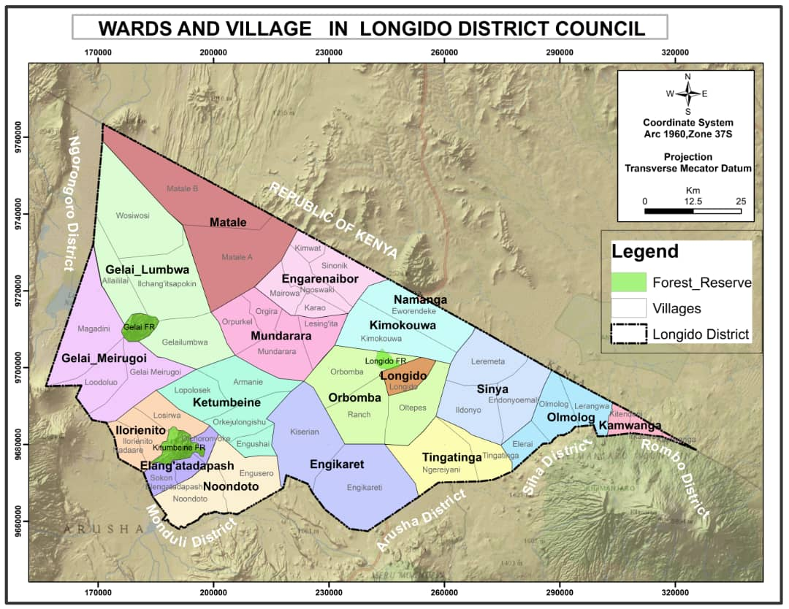

#### Figure 1: Administrative Map of Longido showing 18 Wards

## 2.3 Environmental Baseline Information in Longido District Council

***Terrain of Longido District*:** Longido Council has an altitude ranging from 600 to 2,482 meters above sea level. It is characterized by high gradient ranging from 1685 – 2482m of Longido, Gelai and Ketumbeine mountains. There are low gradient around Lake Natron ranging from 600 to 896m, vast plains and plateaus suitable for grazing and wildlife which ranges from 896 to 1,434m from sea level. The major water body is Lake Natron found in the Western part of the district. Longido is characterized by the presence of Lake Natron, which is a reserved area. Therefore, areas surrounding the lake are ineligible for land certification and . The same applies to a small portion of Oldoinyo Lengai which is a sacred site. A large part of Oldoinyo Lengai is in the Ngorongoro district.

***Districts and other areas bordering Longido District****:* The Longido district is bordered with Ngorongoro, Monduli, Arusha and Siha districts. Presence of Lake Natron, mountains, grazing and wildlife land and bordering with multiple district councils necessitates the need for the LTIP to recognize mixed land uses, proper boundary demarcation and engagement of several stakeholders.

***Major Land Use in Longido District:*** The land use in Longido is traced way back since 1951, where th first government notes was issued, GN No 107, Declaring more than 97% of the land as Game Controlled Areas (GCAs) as per the Fauna Ordinance CAP 303) that later recognized by Wildlife Conservation Act No 12 of 1974; Since in that period it was legal to have GCA within the village land, The Government of Tanzania registred several villages on top of GCA 1979. Among the first registered villages includes Elang’atadapash, Noondoto, Orkejuloongishu, Ilorienito, Longido, and Kamwanga following the registration of villages in the next years. Other related GN includes forest reserves in the GN no 306 of 1958, GN no 354 of 1988, and GN No 372 of 1958 (Ketumbeine, Gelai na Longido forest reserves), Planning areas as GN No 172 of 1996 which declared Longido and Namanga as Planning Areas).

On the other side, since 1951, the proposed GCA has been remained valid as per laws of Tanzania regardless the fact that economic and human activities in the areas of Longido has been changes significantly. For that reason, in the Year 2009, the Government of Tanzania reviewed the wildlife conservation act of 1974 and changed the condition what kind of activity are supposed to be conducted in the area which belongs to GCA. Since the Government understood that, these areas which was declared as GCA are no longer valid due to economic and social development of the settlements, the Law provided a room for the minister responsible for natural resources to review all the areas which belong to GCA and change their use so as to accommodate the current land uses.

The process for approving the changes of land uses form GCA (reserved land) to village land or general land has taken the Government Attention basing on the fact that the settlement development grown at the rate that the land can no longer used as GCA. Several efforts have been conducted by the government, including the formulation of cabinets team of eight ministers from different sector, CSOs engagement in preparation of land uses, control of human and wildlife conflicts, and engagement of various stakeholder so as to agree on land distribution in Longido however, the status quo is the government is still on going with the process of finding amicable solution on how land shall be used.

##### **Table 2: Land categories in Longido District as Since 1951**

|  |  |  |  |
| --- | --- | --- | --- |
| **No.** | **Land Category** | **Area km2** | **Percent** |
| 1 | Village land/ GCA | 7887.16 | 97.6 |
| 2 | Reserved land /forestry | 109.34 | 1.3 |
| 3 | General land | 84.5 | 1.1 |
|  | TOTAL | 8,180 | 100 |

**Source;** Longido district Council, 2023

In Longido district, only 684km2 of land is outside the Game Controlled Area. The prevailing land categories is detailed in **Figure 2**.

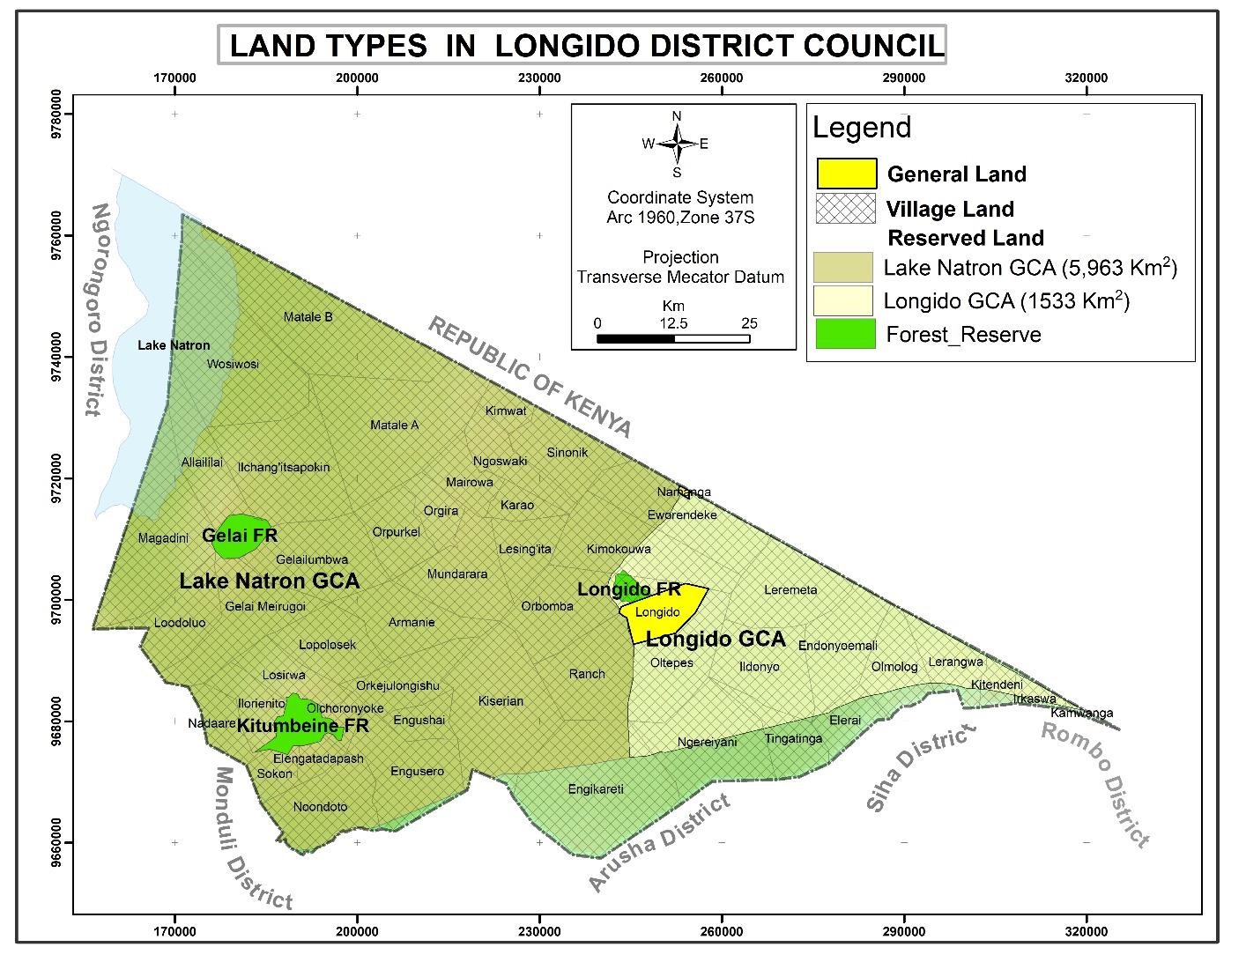

#### Figure 2: Land categories in Longido (Source: Longido District Council, 2023).

***Conservation Areas:*** The district plays an important role in conservation of major ecosystems of Kilimanjaro Amboseli, Tarangire, Manyara, Serengeti – Maasai Mara and Arusha National Parks, Lake Natron RAMSAR Site and Ngorongoro Conservation Area Authority (NCAA). Lake Natron and Longido Game Controlled Areas which cover mostly parts of Longido District are the home of diversity of wild animals. Lake Natron is also a habitat of flamingo which makes it an important ecosystem with high biological and conservation value, an important aspect to be noted for consideration by the LTIP project.

The LTIP project further notes that the presence of conservation areas poses competing interest among stakeholders leading to conflicts among key stakeholders such as the Maasai pastoralists, the wildlife authorities, district councils, farmers, settlement owners and land other stakeholders.

***Wildlife Corridors:*** In the district there are wildlife corridors which will require recognition by the LTIP project during undertaking of the preparation of DLUFP, VLUPs, and rural certification activities. The corridor traverses from Amboseli national park in Kenya through the Longido and Lake Natron Game reserve and connects KINAPA, ANAPA, Manyara, Tarangire, Ngorongoro, Serengeti and Masai Mara national parks (**Figure 3**). The wildlife corridor is expected to receive its own CCRO under the LTIP to foster wildlife management and avoid future encroachments.

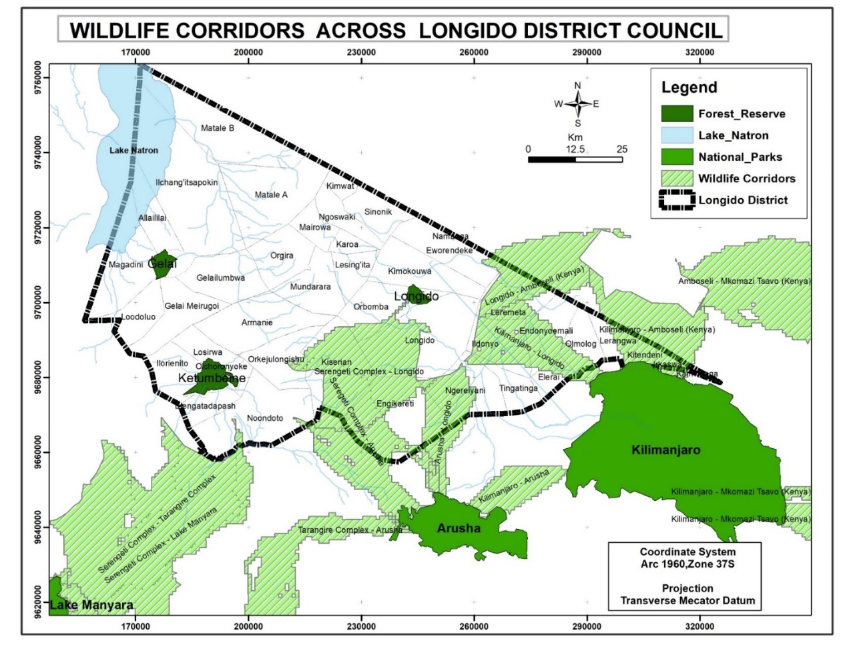

#### Figure 3: Map of Wildlife Corridor in Longido District

***Grazing Land:***The district has vast suitable grazing land (about 590,200 ha equivalents to 72% of the total district area) a large part of which is located in the GCA. (**Figure 4**). Grazing land is also expected to receive its CCRO with the support of LTIP recognizing its use and avoid conflicts with other land uses. This area will be protected from encroachment by other uses.

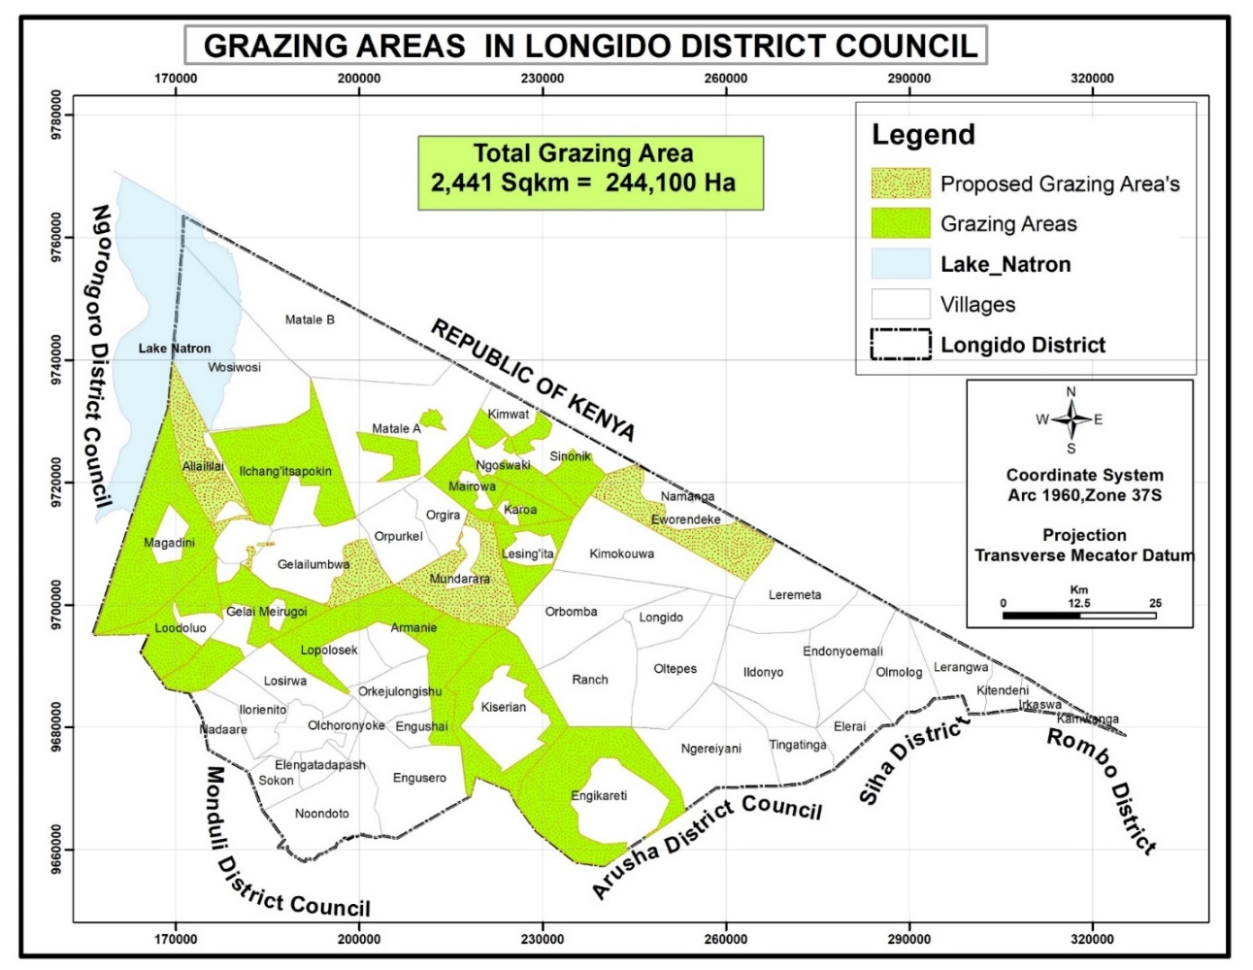

#### Figure 4: Grazing Area in Longido District

***Land certification process, National parks, and other land uses:*** The proposed rural certification will be implemented in a way that is consistent with the safeguards requirements as stipulated in LTIP ESMF, which provides screening criteria to check for environmental and social issues on villages before developing the ESMP for the entire Longido District Council. Based on **Annex 6** of the LTIP ESMF, conservation areas will be recognized as such and no CCROs will be issued in these areas. **Annex 6** of the ESMF further stipulates that in the event where boundaries between the reserve land, national park and individual land parcels are not agreed, LTIP will not proceed with the issuance of CCROs until boundary related conflicts are resolved.

## 2.4 Longido District Council Social Baseline Information

***People and Population:*** According to Population and Housing Census of 2022, the Longido District had a population of 175,915 people of which male are 82,887 and female 93,028. The district is a home of Maasai pastoralists who constitute about 90% of the entire population. Maasai are recognized as Sub-Saharan African Historically Underserved Traditional Local Communities and are still conserving their traditional way of living. According to ESS7, *“Sub-Saharan African Historically Underserved Traditional Local Communities have identities and aspirations that are distinct from mainstream groups in national societies and often are disadvantaged by traditional models of development. In many instances, they are among the most economically marginalized and vulnerable segments of the population. Their economic, social, and legal status frequently limits their capacity to defend their rights to, and interests in, land, territories and natural and cultural resources, and may restrict their ability to participate in and benefit from development projects. In many cases, they do not receive equitable access to project benefits, or benefits are not devised or delivered in a form that is culturally appropriate, and they may not always be adequately consulted about the design or implementation of projects that would profoundly affect their lives or communities. This ESS recognizes that the roles of men and women in indigenous cultures are often different from those in the mainstream groups, and that women and children have frequently been marginalized both within their own communities and as a result of external developments, and may have specific needs”.*

Maasai have got strong traditional systems which are important for decition making:usually they live as a clan in their traditional houses called *‘boma’,* which on average has 6-9 households with 5-8 family members with their own traditional system of living. In Longido district polygamy is also prevalent. This calls for the LTIP Team to observe LTIP’s Vulnerable Group Planning Framework (VGPF) and prepare a Vulnerable Groups Plan (VGP). In particular, stakeholders’ consultation and engagement will require operationalization of the principles of Free, Prior and Informed Consent (FPIC) regarding the preparation of the DLUFP and VLUPs, and the implementation of rural land certification, if conditions requiring FPIC are determined through a social assessment. FPIC shall be activate in case by case

***Land certification process in areas with marginalized groups:*** DLUFP, VLUPs, and the rural land certification team shall ensure that land rights are enjoyed equally by all members of the community (including women in polygamous households) through stakeholders’ engagement and community awareness. Elders, chronically sick people and youth such as *boda-boda* are likely to be excluded from project benefits due to lack of project information. The presence of these marginalized groups calls for the LTIP to ensure that mechanisms are in place for informing and engaging all members of the community including the identified marginalized groups.

***Project Workforce Requirements:*** DLUFP, VLUPs, and the rural land certification process in Longido District Council will require workforce. This situation is likely to attract influx of people in search of employment from within and from outside the country since Longido is located at the border with Kenya. The presence of internal and external movement of people necessitate for the LTIP to pay attention on labor management and eligibility for land rights during issuance of CCRO.

***Economic Activities:***The Longido district economic structure is based on Livestock keeping, wildlife, agriculture, trade, livestock processing industries, beekeeping, and mining as the source of livelihood for the majority of residents. The district is also endowed with wildlife resources which plays the major role in socioeconomic development of the District through ecological, aesthetic, spiritual, and research values. It has vast suitable grazing land (equivalents to 72% of the total district area), tourism attraction, Maasai tradition as well as Namanga One Stop Border Point.

There are seven (7) hunting blocks operated by six (6) hunting companies. These blocks are located within Lake Natron GCA and the Longido GCA (Table 2). DLUFP, VLUPs, and rural land certification activities will require recognition of the hunting blocks to avoid conflicts with the hunting companies.

##### **Table 2: Hunting Blocks**

|  |  |  |
| --- | --- | --- |
| **S/N** | **HUNTING BLOCK NAME** | **HUNTING COMPANY** |
|  | Longido GCA North | Michel Mantheakis Safaris Ltd |
|  | Lake Natron GCA North | Adam Clements Safaris Ltd |
|  | Lake Natron GCA West | Kilombero North Safaris Ltd |
|  | Lake Natron GCA South | Robin Hurt Safaris Ltd |
|  | Lake Natron GCA East | Green Mile Safaris Ltd |
|  | Monduli Juu Open Area | Tanzania Big Game Safaris Ltd |
|  | Engasurai Hunting Area – EWMA | Kilombero North Safaris Ltd |

These diverse economic activities and tourist attractions are required to be recognized during DLUFP, VLUP and rural land certification processes in accordance with the Annex 6 of the LTIP ESMF.

***Social Services:***Longido district council has primary and secondary schools, health centers, churches, mosques and market which are located in all 18 wards, owned by the government, private sector and religious institution. Provision of land parcels for social services such schools, health centers, churches, mosques and markets is critical for the LTIP and necessitate the project to ensure that these facilities are identified and provided with the CCRO to improve their tenure security. The large section has electricity supplied by TANESCO. The main source of drinking water includes boreholes and river streams.

***Road Infrastructure:*** The district has poor road infrastructure that limit transportation services especially during rainy season. There is one National Tarmac Road which passes along Arusha – Namanga - Nairobi route with coverage of 61 km and five (5) Regional roads covering 240 km at gravel level. The gravel road connects the districts of Siha - Longido road, Longido- Ketumbeine - Monduli and Longido - Ngorongoro road. Other road networks in the district are under management of TARURA with total length of 695.81 connects wards to the entire district. This situation will prevent access to grazing lands, and individual plots. LTIP will take note of lack of access roads especially in rural side of the district and ensure that all land parcels including grazing areas and wildlife corridors are identified and provided with access. Indeed, LTIP Team will be required to properly plan transportation for effective implementation of certification of CCROs activities.

***Conflicts over Land resources:***The district also experiences conflicts with conservation authorities over land as the district plays an important role in conservation of major ecosystems of Kilimanjaro Amboseli, Tarangire, Manyara, Serengeti – Maasai Mara and Arusha National Parks, Lake Natron RAMSAR Site and Ngorongoro Conservation Area Authority (NCAA). There are several Government Notices (GNs) within the districts about Game Controlled Area (GCAs) which constitutes large section of the Longido district. LTIP is required to recognize them to avoid conflicts between government ministries and conservation authorities. In particular, LTIP Team are required to closely observe ESS7, ESS6 and ESS10 requirements and provisions during DLUFP, VLUPs and rural land certification activities.

**There is a sense of Insecurity among Longido Communities due to Past Experience on Matters Related to Land:**

Recently the Government of Tanzania in has conducted resettlement activities which have affected positively and negatively Maasai Communities who were residing in National Parks. There are conflicting interests between those who want to conserve environment and those who use particular area for supporting livelihood and way of living. Regardless the efforts which the government has tried to do to mitigate the impacts of the resettlement of the communities which were residing in Ngorongoro National Parks and other similar areas, still they have been voices from different people which has made other Maasai community to be afraid of any intervention on land. The perception of communities and the rumors which are spreading very fast is this project, LTIP is just similar to other government intervention which some of human rights defenders, NGOs, and CSOs are claiming that the process has brought more negative impacts that positive impacts to the Maasai Communities.

The Environmental and Social Teams in Longido are aware on this situation; from the District level to the village level, teams have arranged themselves avoid exacerbating a sense of insecurity among pastoralists on matters related to land in Longido district. In particular, DLUPF and VLUPs shall ensure that the current and future gazing needs within these communities are considered. In addition, there is a need to engage the Longido communities by involving their traditional leaders to enhance project acceptability. This is because the perception of communities in Longido district is negative in most cases when you come with a new project.

***A multitude of NGOs and CSOs operate in Arusha Region and Longido District:*** There are over 20 NGOs/CSOs actively working in Arusha region with different objectives and missions. Their areas of involvement, among others, are tourism, conservation of environment and natural resources governance, good governance and human rights, gender and youth empowerment, socio-economic development and empowerment, climate change and securing land tenure.  In some cases, the activities of these organizations conflict with one another. The pastoralists, who constitute a large section of the population of Longido district trust these NGOs/CSOs. While CBOs, NGOs and CSOs can help LTIP to meet its objectives, they can also confuse the communities, especially if they provide them with incorrect and or distorted information about the project. LTIP is supposed to recognize this risk and strategize the engagement of NGOs/CSOs that work in Arusha and Longido districts. In particular, deliberate efforts to map and understand and subsequently provide them with relevant information about the project are necessary. This will help to make them not confuse LTIP with other land-related projects which have been implemented within their localities.

***GBV/SEA and Diseases Transmission:*** Like other areas in Tanzania, HIVI/AIDs is prevalent in Longido District. Proposed project activities including the preparation of DLUPF, PLUM, VLUP and issuance of CCROs will increase interactions between project workers and local community which is likely to trigger social issues such as GBV/SEA and spread of HIV/AID. In order to avoid GBV/SEA, spread of HIV and AIDS as well as conflicts between project workers and the community the project will require all workers to sign code of conduct (CoC).

# CHAPTER THREE

# LEGAL AND INSTITUTIONAL FRAMEWORK

## 3.1 Introduction

This chapter describe relevant legal and institutional framework governing the preparation of DLUPF, VLUP, DSPs and issuance of CCRO in Longido district. The focus has been made on legislations which provide environmental and social provisions and requirements relevant for the Project. Due to the presence of Maasai who are identified as indigenous by the WB ESF, wildlife animals, national parks, ecological habitat and mountains, the legislation described in this chapters are those which provide guidance to the project and can be made actionable to assist the project on the management of E&S risks and impacts.

## 3.2 Country’s Legal Framework to Guide Land Use Planning and Rural Certification Processes in Longido District

***The Wildlife Conservation Act No. 5 of 2009:*** The Act provides measures for the general conservation of wild animals which includes declaration of wildlife protected areas, game reserves, wetlands and game-controlled area to mention a few. This Act will be implemented by the project through the use of **Annex 6** of the LTIP ESMF. Wildlife Conservation Act is the main legal provision for the establishment of the existing wildlife and wetland protected area and is also the basis for the prevention of any encroachment with the project activities. Longido is endowed with the significant areas for wildlife and national parks which calls for the project to ensure that these areas are identified through guidance provided by **Annex 6** and that no certification will be conducted in national parks.

***The Environmental Management Act (EMA) 2004:*** The Act provide guidance for regulation process in sensitive areas such as rivers, lakes, wetlands, forest areas, and wildlife resource among others. The Act provides a legal framework for coordinating harmonious and conflicting activities by integrating those activities into overall sustainable environmental management system by providing key technical support to Sectoral Ministries. The EMA will be applicable by the LTIP team in Longido during identification of national parks and preparation of DLUPF and VLUP. Specifically, LTIP project in Longido District Council will adhere to 60m buffer zone requirements when issuing CROs for land parcel near lake Natron.

***The National Land Act, No. 4 and 5 of 1999***: The Land Act (1999 recognize that all land in Tanzania belongs to the public, and the President acts as the trustee of the land for the benefit of the people (Land Act, § 1(1)(a)). The Land Act classifies all land in Tanzania into three categories: (1) Reserved Land, (2) General Land, and (3) Village Land (§ 4(4)). The first two categories are governed under the provisions of the Land Act and its regulations. About 68% of all land is Village Land; 30% is Reserved Land and only 2% is General Land in the Country.

These Acts among other things outlines, procedure for land administration, allocation, acquisition, schemes of regularization, land registration and certification, compensation and resource management in both urban and rural areas. The Land Acts contain provisions of critical environmental importance and modalities for stakeholders’ engagement through meeting and public hearing. Both Acts translates the fundamental principles of land policy into the body of the law. One of these fundamental principles is to ensure that land is used productively and that any such use complies with the principles of sustainable development. The preparation of DLUPF, VLUP and the issuance of CCRO will be conducted in accordance with the provisions and requirement stipulated in Land Act. **Section 32 (1) and section 33 of the land use planning Act No. 6 of 2007**provides directives and requirements for the preparation of both DLUFP and VLUPs.

**The land use planning Act, 2007:** LTIP shall prepare the DLUPF and VLUP in accordance to this Act, the act provides that the village must have defined boundaries and gazetted under the GN and described in Village Certificate issued by Commissioner of Land; This act is making reference to other acts especially the Land Act No 4 and 5 to guide the entire process of Land use planning practice in Tanzania.

***The Occupational Health and Safety Act, No. 5 of 2003:*** The law requires employers to provide a good working environment to workers in order to safeguard their health. The LTIP will ensure the implementation of this Act through training to drivers to eradicate incidences and accidents, provide appropriate Personal Protective Equipment (PPE) and welfare facilities such as tents, drinking water and toilet to the direct and indirect implementing teams during preparation of DLUPF, VLUP and the issuance of CCRO.

***The Employment and Labour Relations Act, No. 6 of 2004:*** The Act provide labour rights and protections particularly on Child labour, forced labour and discrimination in the working place and freedom of association. The act prohibits child labour it provides that no child under the age of 14 shall be employed. LTIP will ensure equality in employment, forbid child labour and provide valid employment contracts to direct and indirect workers. The employment contracts for direct and indirect teams will ensure compliance to basic employment standards which include: i) Wage determination that stipulates a minimum term and condition of employment (ii) An employment standard constitutes a term of a contract with an employee unless -a term of the contract contains a term that is more favorable to the employee; and a provision of an agreement alters the employment standard to the extent permitted by the provisions and iii) a provision of any collective agreement, a written law regulating employment, wage determination or exemption granted under section 100. The law also requires provision for health insurance and joining to National compensation funds for labour on employment beyond six months.

***The Urban Planning Act of 2007:*** This is the principal legislation which govern urban planning. The LTIP will prepare detailed planning schemes; undertake public and other stakeholder’s engagement; and subsequent facilitate approval of scheme of regularization as stipulated in this Act. The project will also spearhead preparation of environmental and social assessment of the proposed scheme of regularization.

***Public Health Act of 2012:*** The act stipulates need to consolidate public health through prevention of disease, promotion, safeguard, maintain and protect the health of humans and animals. The presence of LTIP workers may result in the risk of disease transmission and will be addressed through conducting HIV/Aids campaign, provision of handwashing facilities, condoms and dustbins.

***Water Resources Management Act No. 11 of 2009:*** Water Resource Management Act No. 11 of 2009 is the principle legislation governing the utilization and pollution control of the water resources. Specifically, the objective of this Act is to ensure that, water resources are protected, used, developed, conserved, managed and controlled for sustainable development. The LTIP will identify boundaries of Lake Natron, streams, rivers and other water sources in Longido District Council and ensure that such uses are included during preparation of DLUPF and VLUP and will not issue CCRO in such areas to enhance management of water resources.

***The Agriculture and Livestock Policy of 1997* :**  Main objective is to promote and ensure a secure land tenure system to encourage optimal use of land resources and facilitate broad-based social and economic development without upsetting or endangering the ecological balance of the environment. The LTIP P Project implementation in Longido will have adhere to this policy so as to protect the rights of hunters, gatherers, livestock keepers, and specific use endowed to the VGs.

## 3.3 World Bank Environmental and Social Framework

Project ESMF has identified ESS1, ESS2, ESS3, ESS4, ESS5, ESS6, ESS7, ESS8, and ESS10 to be applicable to the LTIP. However, for Longido District Council the following ESSs are applicable and this ESMP describe how specific ESSs is operationalized during preparation of DLUPF, VLUM and the issuance of CCROs:

*ESS1 Assessment and Management of Environmental and Social Risks and Impacts*:

* Screening and of environmental and social risks and impacts to determine level and magnitude of risks and impacts;
* Prepared ESMP for Longido for mitigating identified risk and impacts; monitoring effectiveness of proposed mitigation measures as well as enhancing project benefits.

*ESS2 Labour and Working Conditions;*

* Provision of Valid Employment Contractors to workers for both direct and indirect teams;
* Provide PPE and welfare facilities to workers;
* Training HIV/Aids to project workers of direct and indirect team;

*ESS4 Community Health and Safety*

* Sensitization of community about the project and associated health risks and impacts; and
* Training on HIV/Aids to project workers of direct and indirect team;

ESS5 *Land acquisition, Restriction on Land use and Involuntary Resettlement*

* Sensitization of community about the project and land requirements for access roads, community facilities such as schools, health facilities, markets, cemetery; reactional and open areas; and
* Land donation/acquisition requirements and procedures as stipulated in Resettlement Policy Framework (RPF);

ESS6 *Biodiversity Conservation and Sustainable Management of Living Natural Resources*

* Use of **Annex 6** to ensure that no certification will be undertaken in reserved or conservation land or ecological resources of biodiversity importance such as Lake Natron
* Identification of boundaries of national parks, reserve land, water bodies and wildlife corridors in areas without conflicts with the grazing land.

ESS7 *Sub-Saharan African Historically Underserved Traditional Local Communities*

* Preparation of Vulnerable Groups Plan (VGP) to guide preparation of DLUPF, VLUP and issuance of CCRO in areas occupied by VGs.
* Operationalization of the principles of Free, Prior and Informed Consent (FPIC), if determined applicable.
* Use of Annex 6 of the ESMF to ensure that boundaries between national parks, reserve and grazing land are made clear during preparation of DLUPF, VLUP and before issuance of CCRO.

*ESS10 Stakeholders Engagement and Information Disclosure*

* Sensitization of community about the project
* Formulation and operationalization of Grievance Redress Mechanism (GRM)
* Implementation of District Stakeholders Engagement Forum (DSEF) and National Stakeholders Engagement Forum (NSEF).

# CHAPTER FOUR

# ENVIRONMENTAL AND SOCIAL IMPACTS, RISKS AND MITIGATION MEASURES

## 4.1 Introduction

Based on environment and social (E&S) baseline condition of the project area, the E&S assessment has identified the following likely project benefits, risks and impacts:

## 4.2 Project Social Benefits

In Longido District the LTIP will create the following benefits:

*Security of Tenure:* Issuance of CCROs will enhance security of tenure to the individual, community member and institutions. For instance, issuance of CCROs to the group of people owning jointly grazing lands will protect such resources from individual encroachment and appropriation.

*Capital Creation:* Individuals and communities has potential to use CCROs as collateral to access capital from financial institutions because have legal representation. This will help to accumulate capital which will be invested in other productive economic activities which will stimulate development within Longido district.

*Reduction of Cost Associated with Informal Land Transaction:*The provision of CCROs to Longido communities will enhance reliability in land transaction. CCROs serve as evidence of ownership of land with clear size and boundaries. Equally, it will discourage the practice of multiple sales of the same land to different buyers thus reducing land related conflicts.

*Employments Opportunities:* Rural certification activities in Longido district will require workforce to perform different activities. In total the project will employ approximately over 50 People both skilled and unskilled.

## 4.3 Negative Social Risks and Impacts of Land Use Planning and Rural Land Certification

The following are major negative social impacts associated with LTIP regularization activities in Longido District Council.

1. **DLUFP**; This is a general plan which offers the guidelines for preparation of other plans which includes detailed plans (in town centers within district) and VLUP (In Village land); In the case of Longido, the land use patterns are mainly distributed into three parts; village land, general land and reserved land. On other side, large part of the land falls under GCA (Reserved Land) as per one GN and as village land as per another GN which both GN are still valid to date. DLUFP is likely to revive disagreements of the land use zones and this bring an important attention to LTIP project to make sure different ministries and stakeholders are coming together and agree with the proposals. Some decisions made as part of the DLUFP preparation may also have E&S impacts. These will be assessed, and mitigation measures will be proposed as part of the DLUFP preparation process.
2. **VLUP:** As per analysis, the villages in Longido are having two GN which are contradicting one another. Under GCA, the villages are allowed to use land under guidance of Tanzania Wildlife Authority (TAWA) and there are restrictions of the extent of human activities, the favors are more to wildlife while under GN which identifies as village is more for the people. LTIP project must ensure that the villages have no contradicting GN before preparation of VLUP failure to so it likely to disrupt to ecology of the wildlife. Some decisions made as part of the VLUP preparation may also have E&S impacts. These will be assessed, and mitigation measures will be proposed as part of the VLUP preparation process.
3. **Crosscutting Impacts due to Land use planning and rural land certification**

***Conflict over land ownership and rights****:* In project areas people are living without proper identification of their areas, land size and boundaries with neighbors. During adjudication process the chances of not agreeing to the boundaries might lead to conflict over land especially between Maasai pastoralists and the conservation authorities. In addition, some conflicts might involve proving evidence on who are legal owner of the land parcels to be issued with CCROs. Such cases are likely to happen especially in bouldering land parcels, extended and polygamous families, inherited land parcels and on land parcels which people have contested interest and ownership rights.

Similarly, individuals and communities residing close or who have encroached conservation areas might require CCROs on such land thus leading to conflict with authorities.

***Risk of the Longido communities to attribute LTIP activities to other past government initiatives on land***. The perception that government’s decisions on lands located within pastoral communities are made at the expense of livestock keepers complicate things when new project on land is introduced in the Longido district. Incorrect and or distorted information about the LTIP are likely to confuse the communities and reduce project acceptability.

***Limited Access to CCROs to VGs****:* Longido district is dominated by the Maasai community for more than 70%. These groups are recognized by the ESS 7 of the WB ESF asVGs. The ESS7 describes that *“the VGs are inextricably linked to the land on which they live and the natural resources on which they depend. They are therefore particularly vulnerable if their land and resources are transformed, encroached upon, or significantly degraded. Projects may also undermine language use, cultural practices, institutional arrangements, and religious or spiritual beliefs that Sub-Saharan African Historically Underserved Traditional Local Communities view as essential to their identity or well-being. However, projects may also create important opportunities for Sub-Saharan African Historically Underserved Traditional Local Communities to improve their quality of life and well-being”.*

While Maasai account for around 70% of the population, there is a risk that some do no participate in the LTIP supported land certification program because they do not have access to project information or are not adequately informed about the benefits of this intervention.. Although the country’s regulations do not recognize any ethnic group as indigenous in Tanzania, but the Maasai have been identified by the WB ESF as such, which necessitates the LTIP project to consider and treat this group as VGss. .

***Ineligibility to CCROs****:* According to the **Annex 6** of ESMF and CCRO’s Manual guiding certification process, communities residing within road reserve, protected area and other sensitive areas are not eligible for CCROs. Such areas are reserve lands and are restricted from human settlements and other social economic activities. Considering that land use restriction may be defined or formalized as part of the VLUP process (e.g., establishment of village forest reserves and/or village grazing land), there is a possibility that some individuals using these areas may lose access rights and/or may find out that they are ineligible for CCROs. Community members falling under such circumstances might consider having been denied project benefits related to CCROs. Some may also question the criteria used to establish land use restrictions as part of the VLUP process.

***Inequalities for Women and other Marginalized Group****:* Maasai are predominant ethnic group in Longido district and have conserved their traditional way of living. In Longido, polygamous are prevalent and people live as a clan in *‘bomas’*. In such cases women have less access to the rights to own land. In addition, marginalized groups such as elders, chronically ill people and the youth have less chances to get CCROs due lack of project information, and this could formalize inequalities between men and women regarding access to CCROs.

***Gender Based Violence, and SEA****:* In Longido, community members with access to project resources such employment, income and power over others might subject subordinates, children, spouses, and people from low-income status to GBV and SEA.

***Influx of Laborers****:* Mass rural certification will involve large number of workers from within and outside the project areas. Interactions of project workers among themselves and local community are likely to accelerate the spread of STI, crimes as well as over burdening of available social services.

***Inaccessibility of Project Sites****:* Large section of Longido district is served with gravel and dirty roads which limits transportation especially during rainy season. Land certification process is likely to delay during rainy seasons and the issue of health and safety due to accidents

***Possibility of Issuing CCROs to Non-nationals****:* Longido district is neighboring Kenya which its nationals have much interaction to Longido community thus putting risk of issuing CCROs to non-citizens due to demand of land.

## Project Positive Environmental Impacts of **Land Use Planning and** Land Certification

The following are positive environmental impacts of this project in Longido District Council:

*Enhancement of protection of sensitive areas and minimization of Conflicts:* Longido district plays an important role in conservation. DLUFP, VLUPs and the issuance of CCROs will recognize all protected areas including tourist sites which will reduce their encroachment and conflicts between local community and conservation authorities. The preparation of VLUPs entails the establishment of protected areas such as forest reserves, which is an important step toward the preservation of these areas.

*Protection of Common resources:* In Longido district, group of people owning jointly grazing lands will be issued with CCROs. This will help to use the land sustainably and conserve and rangelands and water resources.

## 4.5 Negative Environmental Impacts of **Land Use Planning and** Land Certification

The major negative environmental impacts of regularization process in Longido District Council are:

*Encroachment of Sensitive Areas:* Important conservation areas such as major ecosystems of Kilimanjaro Amboseli, Tarangire, Manyara, Serengeti – Maasai Mara and Arusha National Parks, Lake Natron RAMSAR Site and Ngorongoro Conservation Area Authority (NCAA) are situated within Longido district. Inadequate and failure to recognize such areas during rural certification might lead to their encroachment.

*Soil Erosion and Solid Waste Generation:* Installation of the beacons may result in localized soil erosion due to the presence of loose soil around the beacon. Also, fabrication of beacons activities will involve sourcing materials from quarries and borrow pits such as gravel, sand, which may result in land degradation and soil erosion. In addition, during certification process project workers will generate solid and liquid wastes such as plastic, food and human waste leading to land pollution.

*Health and Safety Hazards:* Fabrication, transportation and subsequent installation of beacons might lead to incidences and accidents causing injuries and fatalities.

## 4.6 Mitigation Measures of the Identified Impact

This section describes mitigation measures for the project adverse impacts and proposed measures for enhancing positive one as well as associated costs. **Table 3** is the impacts and mitigation matrix for rural certification for Longido District. It detailed the proposed impacts, mitigation measures, responsible party, timeframe and costs that will be overseen and managed by LTIP project implementation team.

##### **Table 3: Mitigation Measures of Identified Impacts**

| S/N | Potential Social Impacts | Mitigation Measures | Cost Estimates (TZS) | Responsible | | Implementation Time Framework |
| --- | --- | --- | --- | --- | --- | --- |
| Implementation | Supervision |
| Negative Project Social Impacts | | | | | | |
| 1 | Negative economic and social impacts relating to restrictions on land use resulting from the DLUFP and VLUP processes | * Undertake adequate E&S assessment of the proposed DLUFP and VLUP to determine the magnitude of impacts. * Devise mitigation measures to address risks and impacts related to the proposed DLUFP and VLUP in accordance with the World Bank’s ESF. | 1,000,000 | * Longido District Council E&S Team * NGOS? | ESMT | During preparation of  DLUPF and VLUP. |
| 2 | Deepening of  insecurity on the fate of lands among Longido communities. | * Provide communities with correct project information * Strategize engagement of traditional leaders * Ensure present and future gazing needs are taken into consideration during formulation of DLUPF and LUPs without prejudice the need of other land uses and conservation of environment | 30,000,000 | * Participatory Land Use Management (PLUM) Team. * E&S Team * CSO | ESMT | During preparation of  DLUPF, VLUP and issuance of CCRO |
| 3 | Confusion of communities with incorrect information about the project. | * Map NGOs/CSOs and understand their mission and objectives. * Provide NGOs/CSOs with project information and where necessary engage them to create sensitization to the community. | 5,000,000/= | * E&S Team * Participatory Land Use Management (PLUM) Team. | ESMT | During preparation of  DLUPF, VLUP & throughout the project. |
| 4 | Conflict over land ownership and rights | * Formulation and operationalization of GRM * Capacity building and awareness creation to local leaders on conflict resolution. * Sensitization on the importance of joint land titling. * Educate men on the importance of including their wives on CCROs. | 30,000,000/= | * Longido District Council E&S Team * Ward Executive Officer (WEO), * Ward Community Development Officer (CDO) * Village Leaders | ESMT | During preparation of  DLUPF, VLUP, and issuance of CCROs. |
| 5 | Poor certification among the VGs | * Preparation of Vulnerable Group Plan (VGP) * Operationalize/implement the Free, Prior, Informed Consent (FPIC) * Use of both individual and collective CCROs | 20,000,000 | * Longido District Council E&S Team * Ward Executive Officer (WEO), * Ward Community Development Officer (CDO) * Village Leaders | ESMT | Before preparation of  DLUPF, VLUP, and issuance of CCROs. |
| 6 | Ineligibility to CCROs | * Identification of all households ineligible to receive CCROs and formulation of advice on how to address their situation. * Identification of households and parcels close and within 60 m of the conservation and sensitive areas. * Awareness on ineligibility for CCROs. * Liaise with NEMC, TANAPA, Ngorongoro Conservation Area, * Basin Authority for further guidance, and the Ministry of Natural Resources and Tourism for further guidance. * TANROADS and TARURA | 10,000,000/= | * Longido District E&S Team * Participatory Land Use Management Team (PLUM) * National Environmental Management Council (NEMC) * TANROADS& * TARURA * TANAPA, Ngorongoro Conservation Area, * Basin Authority * Ministry of Natural Resources and Tourism for further guidance | ESMT | During identification of Parcels. |
| 1. 7 | The CCRO issuance process formalize land access inequalities for Women and other Marginalized Group | * Identification of marginalized groups such as women, elders, chronically ill persons and youth * Sensitization on importance of CCROs and other project benefits. | 10,000,000/= | * Longido District E&S Team * Ward Executive Officer (WEO), * Ward Community Development Officer (CDO) * Village Leaders * CSOs. | ESMT | During Project Sensitization and identification |
| 7 | Gender Based Violence | * Engage Police Gender Desk to train Project staff on GBV/SEA. * All LTIP staff to sign a code of conduct which include GBV/SEA issues. * Develop and operationalize GBV Action Plan for the District. * Disseminate information about the GRM and encourage population to report misconducts * Engage relevant government agencies and/ or NGOs in the district who provide support to survivors on GBV and SEA such as assistance for medical care, psychosocial support, legal redress, safety, etc. where necessary. | 10,000,000/= | * Longido District E&S Team * Ward Executive Officer (WEO), * Ward Community Development Officer (CDO) * Village Leaders * Private Companies involved in rural certification activities. | ESMT | Before placement of employees and during rural certification process. |
| 8 | Influx of Laborers | * Community awareness on STIs transmission and basic hygiene practice and crimes * Give employment priority to unskilled laborers from within project areas. * Provision of welfare facilities such as water, toilets and food vending to project workers. | 5,000,000/= | * Longido District Council Certification Office (CUCO) * Longido District E&S Team * Village Leaders * Private Companies involved in rural certification activities. | **ESMT** | During Urban Certification Process. |
| 9 | Inaccessibility of Project Sites | * Target implementation of rural certification of villages not accessible during rainy season during dry season. * Provide suitable transport facilities. |  | * Longido District Council Urban Certification Office (CUCO): * Longido District Council E&S Team * District Land Use Plan Framework (DLUPF) Team * Participatory Land Use Management (PLUM) Team | **ESMT** | During Rural Certification Process |
| 10 | Possibility of Issuing CCROs to Non-nationals | * Make use of National IDs during issuance of CCROs * Rural formalization team to work closely with local leaders to confirm citizenship of Project beneficiaries. | 10,000,000/= | * Longido District Council Urban Certification Office (CUCO * Longido District E&S Team * Ward Executive Officer (WEO), * Ward Community Development Officer (CDO) * Village Leaders |  | During Rural Certification Process |
|  |  |  |  |  |  |  |
| Negative Project Environmental Impacts | | | | | | |
| 1 | Negative environmental impacts relating to land use classification adjustments resulting from Review of the GN | * Undertake adequate E&S assessment of the proposed DLUFP and VLUP to determine the magnitude of impacts. * Devise mitigation measures to address risks and impacts related to the proposed DLUFP and VLUP in accordance with the World Bank’s ESF. | ? | * PLUM * E&S Team | ESMT | During preparation of  DLUPF and VLUP. |
| 2 | Encroachment of Environmental Sensitive Areas | * Make use of Annex 6 of the ESMF to ensure that boundaries between national parks, reserve and grazing land are made clear during preparation of DLUPF, VLUP and before issuance of CCRO issuance. | 5,000,000/= | * PLUM * E&S Team * National Environmental Management Council (NEMC) * TANROADS& * TARURA * TANAPA, * Ngorongoro Conservation Area, * Basin Authority * Ministry of Natural Resources and Tourism. | ESMT | Before placement of employees and during rural certification process. |
| 3 | Soil Erosion and Solid Waste Generation | * Undertake tree and grass planting * Provision of dustbins in all project areas * Use of welfare facilities such as toilets and water | 5,000,000/= | * Longido District Council E&S Team * Private Companies involved in certification activities. * Village Leaders | **ESMT** | During Rural Certification Process. |
| 4 | Health and Safety Hazards | * Provision of PPEs (Mask, Boots, Gloves and Helmet) to workers. * Training drivers of direct and indirect teams on road safety * Provide Health and safety Training to project workers | 30,000,000/= | * Longido District Council E&S Team * Private Companies involved in certification activities. * Village Leaders | **ESMT** | During Rural Certification Process. |

# CHAPTER FIVE

# Monitoring of Environmental and Social Impacts

## 5.1 Introduction

Monitoring establishes benchmarks which are used to assess the level of compliance with ESMP. Monitoring will involve the continuous or periodic review of mitigation activities to determine their effectiveness. The monitoring plan in this report specifies the institution arrangement for execution of ESMP. In particular, it clarifies type of monitoring, who will carry out monitoring and what other inputs such as training are necessary.

The objectives of Environmental and Social monitoring plan are:

* To monitor the effectiveness and implementation of ESMP during planning and CCROs issuance phases of proposed mitigation measures;
* To confirm compliance with environmental, social and safety legislation/regulations during certification as well as safeguards tools and instrument in pace;
* To control the risks and ecological/social impacts;
* To ensure best practices management as a commitment for continuous improvement in environmental and social performance;
* To provide environmental information to community/stakeholders;
* To provide early warning signals on potential environmental degradation for appropriate actions to be taken so as to prevent or minimize environmental consequences;

The **Table 4** below summarizes monitoring plan for urban certification in Longido District Council:

##### **Table 4: Social and Environmental Monitoring Plan**

| **S/N** | **Environmental/ Social Impacts** | **Monitoring Parameters** | **Targets/Legal Standards** | **Monitoring Methods** | **Frequency /Duration** | **Host institution**  **Supervising institutions** | **Monitoring Budget** |
| --- | --- | --- | --- | --- | --- | --- | --- |
|  | **Land Use Planning** | | | | | | |
|  | E&S impacts of land use planning | Compliance of the ESS 1-8 and ESS 10 | 100% | Reports on Implementation of ESMP | Quarterly | ESMT & PIT |  |
|  | **Enhancement of Social Benefits** | | | | | | |
|  | Security of Tenure | No. of CCROs issued in each Village |  | ILMIS data | Quarterly | ESMT & PIT |  |
|  | Capital Creation | No. of Beneficiaries using CCROs to secure capital. |  | Project report | Quarterly | ESMT & PIT |  |
|  | Reduction of land conflicts | No. of land conflicts identified and resolved as part of the CCRO issuance process |  | Project report | Quarterly | ESMT & PIT |  |
|  | Employments Opportunities | No. of people employed | 174 | Report | Quarterly | ESMT & PIT |  |
| **Enhancement of Environmental Benefits** | | | | | | | |
|  | Enhancement of protection of sensitive areas and minimization of Conflicts | Number of CCRO issued in sensitive areas | 0 | Report | Quarterly | ESMT & PIT |  |
|  | Number and hectares or village land declared as forest reserve |  |  |  |  |  |
|  | Protection of Common resources | Presence of group of people owning jointly grazing lands issued with CCROs |  | Scheme of regularization & Reports | Annually | ESMT & PIT |  |
| **Social Negative Impacts** | | | | | | | |
|  | Enhanced communities understanding of LTIP activities | * Acceptance of the LTIP activities by the communities in the Longido district * Participation of traditional pastoral leaders in LTIP activities. |  | Reports | Quarterly | ESMT & PIT |  |
|  | Poor certification among the Indigenous People (IPs) | Percentage of CCROs issued under the name of Maasai Indigenous People | 80% | ILMIS data | Quarterly | ESMT & PIT |  |
|  | Ineligibility to CCROs | No of parcels identified as ineligible for rural land certification | N/A | Report | Quarterly | ESMT & PIT |  |
|  | Inequalities for Women and Other Marginalized Group | Tailored local information campaigns organized with the support of NGO-CSOs |  |  |  |  |  |
|  | Project staff have been training on women land rights and how to encourage the registration of women’s land rights as part of the CCRO process |  |  |  |  |  |
|  | Percentage of Women with CCROs. | 30% | Report | Quarterly | ESMT & PIT |  |
|  |  | Marginalized Group with CCROs. | 10% | ILMIS Report | Quarterly | ESMT & PIT |  |
|  | Gender Based Violation | No. of GBV/SEA cases reported. | 0 | Report | Quarterly | ESMT & PIT |  |
|  | Influx of Laborers | Percentage of laborers employed from within the project areas. | 40% | Report | Quarterly | ESMT & PIT |  |
|  | Inaccessibility of Project Sites | No. of people located in accessible villages during rain seasons with CCROs. |  | Report | Quarterly | ESMT & PIT |  |
| **Environmental Negative Impacts** | | | | | | | |
|  | Waste Management | No. of dustbins provided in three Mitaas | 150 dustbins @ village 3 | Report and observation | Quarterly | ESMT & PIT |  |
|  | Health and Safety Hazards | No. of incidence and accidents reported. | 0 | Report | Quarterly | ESMT & PIT |  |

# CHAPTER SIX

# INSTITUTIONAL ARRANGEMENTS FOR IMPLEMENTATION OF ESMP IN LONGIDO DISTRICT COUNCIL

## 6.1 Introduction

The implementation of ESMP will follow the plan stipulated in ESMF. For Longido District Council the following will be involved in the implementation of this ESMP



## 6.2 ESMP Implementing Institutions in Longido District Council

*Longido District Council Rural Certification Office :* This will be responsible for daily certification activities which will involve support to Longido District Council E&S Team.

*Longido District Council E&S Team:* This will be responsible for implementation of the E&S activities including the proposed mitigation and enhancement measures with the support from CUCO.

*District Land Use Plan Framework (DLUPF) Team:* This will be responsible for identifying different uses within the district. In Longido, unique land uses such as national parks, wildlife corridors, grazing land, Lake Natron and other uses will be identified and included in the DLUPF.

*Participatory Land Use Management (PLUM)* Team: This will be responsible for identification of households residing along road reserve, gullies and river streams.

*National Environmental Management Council (NEMC), Northen Zone:* Will provide further guidance on households residing along, gullies and river streams.

*Tanzania Rural and Urban Road Agency (TARURA) and Tanzania Road Agency (TANROADS), Arusha Region:* Will provide further guidance on households residing along the roads including payment of compensation where applicable.

*Ward and Village Leaders:*These will be involved in conflict resolutions through operationalization of project GRM, identification of marginalized groups such as women, elders, chronically ill persons and youth, and sensitization on importance of CCROs, waste management, GBV/SEA matters, health and safety and other project related benefits.

*Civil Society Organization(CSOs) and Non Governmental Organization (NGOs)*: During mapping of the CSOs-NGOs in Longido, the following were identified: UCRT, CORDS, PINGOZ, OIKOS, WWF and SMART CCF. They will be responsible for ensuring engagement of marginalized and vulnerable people in this project. Sensitization on importance of CCROs and other project benefits, importance of joint titling and GBV/SEA matters. For those CSO-NGOs which shall be involved with DLUFP, VLUPs, and CCRO , they will be responsible for provision of PPEs (mask, boots, gloves and helmet) to workers; training drivers of direct and indirect teams on road safety; provide health and safety training to project workers; provision of dustbins in all project areas; provision of welfare facilities such as toilets and water; tree and grass planting; dust suppression.

## 

## 

## 

## 

## 6.3 Supervision and Monitoring Roles

*Project Environment and Social Management Team (ESMT):* shall be responsible for ensuring compliance with ESMPs. In particular, the team will conduct regular audits and prepare the reports that demonstrate the suggested ESMP are being implemented accordingly. The team will be required to submit monthly reports to MLHHSD. The MLHHSD through PCU then will be required to submit quarterly reports on ESMP implementation to the World Bank.

## 6.4 Capacity Development and Training

Capacity development training for LTIP is stipulated in ESMF. For Longido District council the following training have been provided to E&S Team at LGAs levels to enhance their capacity during preparation of DLUPF (**Table 5**). Several awareness raising meetings were also conducted with different stakeholders during preparation of DLUPF.

##### **Table 5: Training conducted to Longido E&S Team**

|  |  |  |  |
| --- | --- | --- | --- |
| **S/N** | **Name of Training** | **Training Institution** | **Date** |
|  | Environmental and Social Framework Training to LGAs E&S Teams | World Bank | 13th – 14th December 2022 |

Other E&S trainings are planned for Longido District Council to enhance their capacity to implement this ESMP will be as follow.

1. Health and safety training to project drivers and field teams.
2. Training on implementation of ESMP to private firms to be conducted prior to certification process;
3. Training of code of conducts for GBV/SEA and ethics practice to ESMT and Longido District Council E&S Team to be conducted on June 2024;

# CHAPTER SEVEN

# CONCLUSIONS AND RECOMMENDATIONS

## 7.1 Introduction

This ESMP is specifically for Longido District Council LTIP activities. It proposes mitigation measures to minimize the adverse impacts, while enhancing the positive ones. The assessment and evaluation process of the proposed project activities indicates that the project will bring net social benefits within the project area. Negative implications of this project have been identified, and need to be mitigated, in order to make this project environmental and socially sound.

## 7.2 Conclusions

Given the importance of multiple land uses in Longido and the presence of VGs, ESMP shall be an important tool for facilitation of stakeholders engagement and sensitization so as to affirm with proposed land uses, village boundaries and access to CCRO. Furthermore, this District ESMP shall be supported with Village VGP so as to ensure inclusiveness of the VGs who are the dominant in the District. On the other side, project might trigger FPIC under the following conditions

1. LTIP project adverse impacts on land and natural resources subject to traditional ownership or under customary use or occupation;
2. LTIP project can relocation of Indigenous Peoples/Sub-Saharan African Historically Underserved Traditional Local Communities from land and natural resources subject to traditional ownership or under customary use or occupation; or
3. LTIP project activities has significant impacts on Indigenous Peoples/Sub-Saharan African Historically Underserved Traditional Local Communities’ cultural heritage that is material to the identity and/or cultural, ceremonial, or spiritual aspects of the affected Indigenous Peoples/Sub-Saharan African Histori- cally Underserved Traditional Local Communities’ lives.

However, as per screening conducted in Longido and experiences from previous related efforts ; The project activities in Longido is likely not to need FPIC application. In the case needed, Team shall follow the procedures as provided in ESMF and VGP

The social benefits of this project to include enhanced security of tenure, capital creation, effective land control and management, reduction of cost associated with informal land transaction, and employments opportunities.

Apart from the positive impacts, this ESMP also identified some negative implications associated with the proposed interventions, which need to be mitigated in order to ensure project acceptability and sustainability. Among the negative impacts are: Conflict over land use and land rights, ineligibility for some people to obtain CCROs, inequalities for women and other marginalized group, likely of emergence of gender-based violation, influx of laborers, soil erosion and dust, generation of waste, and health and safety hazards.

To address the aforementioned risks and impacts, the ESMP include a comprehensive Environmental and Social Management Plan (ESMP) and a Monitoring Plan for proper implementation of the project and reduction of the negative effects from the project. The MLHHD is committed to effect this ESMP through ensuring that enough budget, human resources and logistics are available.

## 7.3 Recommendations

* All Villages where the project is implemented should have the copy of this ESMP,
* NGOs to be hired to conduct certification process in Longido District Council should be given this ESMP as part of the contract to ensure its implementations team in Longido District Council with Support from ESMT and the Bank shall prepare the VGP before starting preparation of DLUFP, VLUP and Issuance of CCRO.
* PLUM (ES TEAM) shall ensure meaningful consultation of all key and relevant stakeholders
* Free, Prior and Informed Consent FPCI will be activated when found necessary in the specific villages
* Adequate budget should be allocated to facilitate implementation of the mitigation measures to avoid project impacts to the environment and the community and enhance project benefits.
* Training to all stakeholder on E&S issues is key for achieving the objectives of this ESMP. All key stakeholders identified in this ESMP must be trained to facilitate smooth implementation of the E&S issues during project implementation.

**Appendix 1**: Due Diligence in the Villages where there is Existing VLUP

|  |  |  |
| --- | --- | --- |
| Sn | Checklist | Description |
| 1 | Is the village land uses approved through village Assembly | 1. Conduct environmental and social assessment of the proposed land use plan basing on ESMF, ESCP, VGPF, SEP and RAP 2. Basing on 1 above, confirm if the plan complies with ESF 3. Check on supporting documents used to approve the VLUP (Entry Meeting Minutes and Approval of VLUP Meeting minutes) 4. Check on engagement of women, youth and other minority community members |
| 2 | Is the proposed land use compactible with the GN | 1. Check in the issues related to Reserve land and Village land 2. Check if there are land uses conflicts between different land users (Environmental Conservation vs land uses) |
| 3 | Is the VLUP endowed by District Council | 1. Check on District Statement on Regards to proposed land use (Normally written in a minute which are submitted to approval authorities for gazettement) |
| 4 | Is the VLUP Gazetted | 1. Confirm on gazettement status and if does not conflicting with other gazettement |

Note: The results from this table shall open a room for further discussion basing on different cases for proceeding with other rural certification process